**Adding Your Own Ribbon Elements to Excel**

Here is some code to put in your VBA project to add your own commands to the Excel Ribbon.

These new commands appear in the Ribbon as “Add-ins” in a section called “Custom Toolbars.”

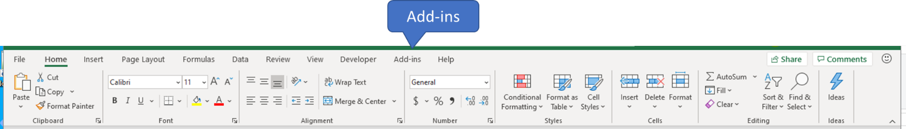

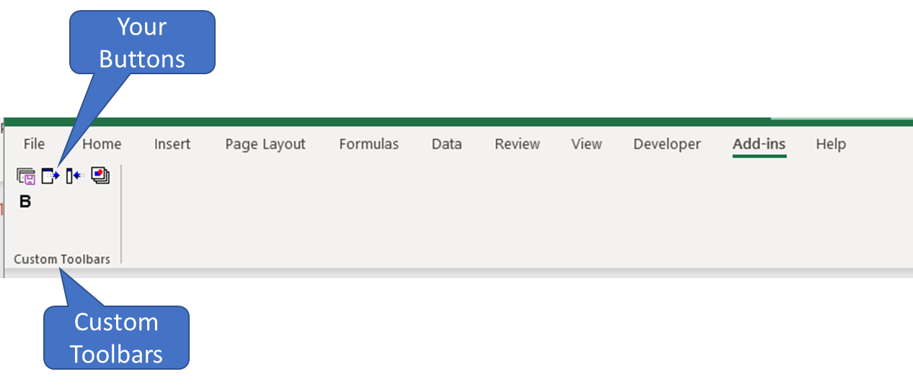

**Instructions for using:**

1. The code below can go in any VBA Code Module
2. Give your command bar a name by specifying CommandBarName. Spaces are allowed.
3. Specify the routine to execute in NewButton.OnAction
4. Specify the caption that appears when the user hovers over the button in NewButton.Caption. Spaces are allowed.
5. Specify your button’s appearance in NewButton.FaceID. There is an extensive collection of images in <https://bettersolutions.com/vba/ribbon/face-ids-2003.htm>

**How it works:**

1. Auto_Open executes when you launch your workbook
2. Auto_Open then
   1. Deletes CommandBarName if it already exists
   2. Creates CommandBarName
   3. Builds the button(s)
   4. Makes CommandBarName visible
3. When the user hovers over a button, they see “CommandBarName: ButtonCaption”
4. Auto_Close executes when you close your workbook to delete the command bar

**How I use it:**

* I have a set of buttons in my Personal.xlsb that are available in all my workbooks
* I have unique buttons for each workbook that allow me to execute routines quickly and easily

Option Explicit

Private Const CommandBarName As String = "Table Builder"

Private Type CodeType

CustomBar As CommandBar

End Type

Private This As CodeType

Public Sub Auto_Open()

' https://bettersolutions.com/vba/ribbon/face-ids-2003.htm for FaceIDs

On Error Resume Next

CommandBars(CommandBarName).Delete

On Error GoTo 0

Set This.CustomBar = CommandBars.Add(Name:=CommandBarName)

BuildButton "RourineToExecute", "Button Caption", 81 ' Capital B

This.CustomBar.Visible = True

End Sub ' Auto_Open

Private Sub BuildButton( _

ByVal RoutineToExecute As String, _

ByVal Caption As String, _

ByVal FaceID As Long)

' Build one button on the command bar

Dim NewButton As CommandBarButton

Set NewButton = This.CustomBar.Controls.Add(msoControlButton)

NewButton.OnAction = RoutineToExecute

NewButton.Caption = Caption

NewButton.FaceID = FaceID

End Sub ' BuildButton

Public Sub Auto_Close()

On Error Resume Next

CommandBars(CommandBarName).Delete

On Error GoTo 0

End Sub ' Auto_Close